KC GROUP OF RESEARCH & PROFESSIONAL INSITITUES

PANDOGA|UNA

- Practical File of
Advanced Java Lab



Subject Code: CS-611

Department of Computer Science & Engineering

Submitted By:Aryaman Sharma
(22011403007)

Submitted To: ER PRIYANKA
AP (CSE Dpt.)

Index
SNO. | Practical NAME | Teacher sign
1. | Write a JAVA servlet program to implement a dynamic HTML using Servlet (username and Password should be accepted using HTML and displayed using a servlet).
2. | Write a JAVA servlet program to implement and demonstrate get() and post methods (using HTTP servlet class).
3. | Write a JSP program to demonstrate the import attribute.
4. | Write a JAVA servlet program using cookies to remember user preferences.
5. | Write a JAVA jsp program to implement verification of a particular user login and display a welcome page.
6. | Write a JAVA servlet program to auto web page refresh (consider a webpage which is displaying date and time or stock market status. For all such type of pages, you would need to refresh your web page regularly; java servlet makes this job easy by providing refresh automatically after a given interval).
7. | Write a program to develop aswing application with different layouts.

Practical-1

Write a JAVA servlet program to implement a dynamic HTML using Servlet (username and Password should be accepted using HTML and displayed using a servlet).

Here's a code for a JAVA servlet program that accepts user name and password using HTML and prints the same using a servlet:

import java.io.*;
import javax.servlet.*;
import javax.servlet.http.*;

public class LoginServlet extends HttpServlet {
public void doGet(HttpServletRequest request, HttpServletResponse response)
throws ServletException, IOException {

// get user name and password from the HTML form
String userName = request.getParameter("userName");
String password = request.getParameter("password");

// set response content type
response.setContentType("text/html");

// write output to the response
PrintWriter out = response.getWriter();
out.println("<html>");
out.println("<head>");
out.println("<title>LoginServlet Output</title>");
out.println("</head>");
out.println("<body>");
out.println("<h1>LoginServlet Output</h1>");
out.println("<p>Username: " + userName + "</p>");
out.println("<p>Password: " + password + "</p>");
out.println("</body>");
out.println("</html>");
}
}

To use this servlet, create an HTML form that accepts user name and password and submits it to the servlet. For example:

Html

<!DOCTYPE html>
<html>
<head>
<title>Login</title>
</head>
<body>
<h1>Login</h1>
<form action="LoginServlet" method="get">
<label for="userName">User Name:</label>
<input type="text" id="userName" name="userName"><br><br>
<label for="password">Password:</label>
<input type="password" id="password" name="password"><br><br>
<input type="submit" value="Submit">
</form>
</body>
</html>
```

Output:
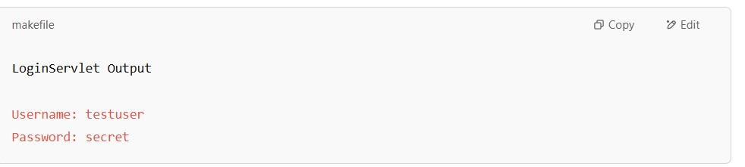

Practical-2

Write a JAVA servlet program to implement and demonstrate get() and post methods (using HTTP servlet class).

public class MyServlet extends HttpServlet {

private static final long serialVersionUID = 1L;

public void doGet(HttpServletRequest request, HttpServletResponse response) throws ServletException, IOException {
response.setContentType("text/html");
PrintWriter out = response.getWriter();
out.println("<html>");
out.println("<head>");
out.println("<title>Get Method Demo</title>");
out.println("</head>");
out.println("<body>");
out.println("<h1>Using Get Method</h1>");
out.println("<p>Get method was called from the servlet.</p>");
out.println("</body>");
out.println("</html>");
}

public void doPost(HttpServletRequest request, HttpServletResponse response) throws ServletException, IOException {
response.setContentType("text/html");
PrintWriter out = response.getWriter();
out.println("<html>");
out.println("<head>");
out.println("<title>Post Method Demo</title>");
out.println("</head>");
out.println("<body>");
out.println("<h1>Using Post Method</h1>");
out.println("<p>Post method was called from the servlet.</p>");
out.println("</body>");
out.println("</html>");
}
}

In this servlet program, the MyServlet class extends from the HttpServlet class and overrides the doGet() and doPost() methods to handle HTTP GET and POST requests. In the doGet() method, it returns an HTML page with the text "Using Get Method" stating that the servlet was called using the GET method. In the doPost() method, it returns an HTML page with the text "Using Post Method" stating that the servlet was called using the POST method.

Finally, the HTML pages are displayed to the user in a web browser on submitting the GET or POST request for our sample web application.

Output:
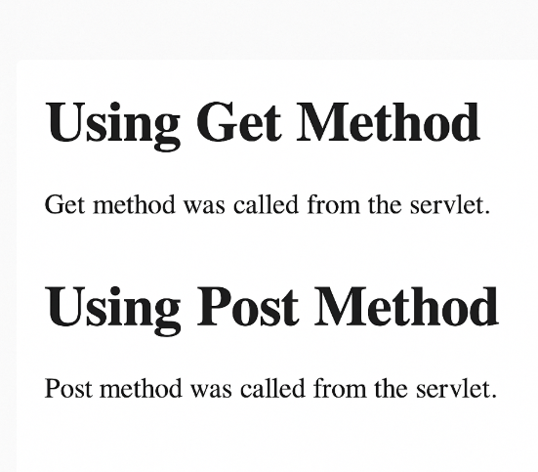

Practical-3

Write a JSP program to demonstrate the import attribute.

welcome.jsp
<%@ page import="java.util.Date" %>
<html>
<head>
<title>import page directive example</title>
</head>
<body>
Current date: <%= new Date() %>
</body>
</html>

web.xml
<web-app>

<welcome-file-list>
<welcome-file>welcome.jsp</welcome-file>
</welcome-file-list>

</web-app>

Output :
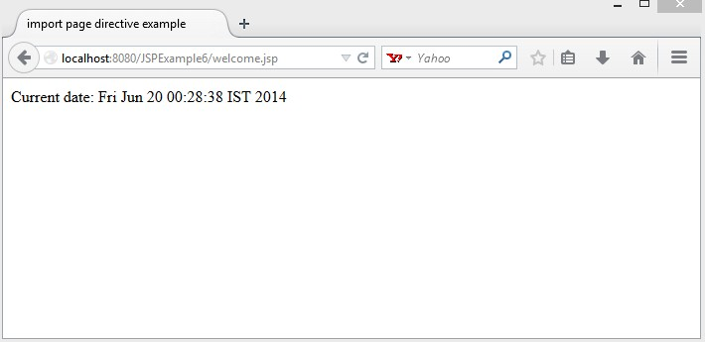

Practical-4

Write a JAVA servlet program using cookies to remember user preferences.

import javax.servlet.*;
import javax.servlet.http.*;

public class UserPreferencesServlet extends HttpServlet {
public void doGet(HttpServletRequest request, HttpServletResponse response) import java.io.*

throws ServletException, IOException {

// Get the user's preferences from the request parameters

String fontColor = request.getParameter("fontColor");
String fontSize = request.getParameter("fontSize");

// Create a cookie for each preference
Cookie fontColorCookie = new Cookie("fontColor", fontColor);
Cookie fontSizeCookie = new Cookie("fontSize", fontSize);

// Set the cookies to expire in 1 hour

fontColorCookie.setMaxAge(60*60);
fontSizeCookie.setMaxAge(60*60);

// Add the cookies to the response
response.addCookie(fontColorCookie);
response.addCookie(fontSizeCookie);

// Set the response content type
response.setContentType("text/html");

// Write the HTML response
PrintWriter out = response.getWriter();
out.println("<html><body>");
out.println("<h1>User Preferences Set</h1>");

out.println("<p>Font Color: " + fontColor + "</p>");
out.println("<p>Font Size: " + fontSize + "</p>");
out.println("</body></html>");
}

public void doPost(HttpServletRequest request, HttpServletResponse response)
throws ServletException, IOException {
doGet(request, response);
}
}
```

Output:
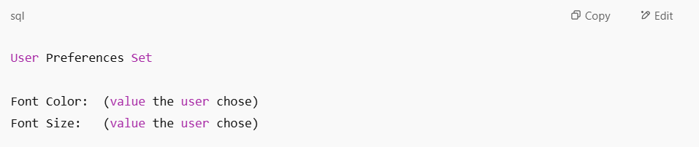

Practical 5

Write a JAVA jsp program to implement verification of a particular user login and display a welcome page.

login.jsp

<html>
<head> <title> Login page </title>
</head>
<body>
<form action="validation.jsp">
USER ID: <input type="text" name="uname" /> <br>
PASSWORD: <input type="password" name="password" /> <br>
<input type="submit" value="submit" >
</form>
</body>
</html>

validation.jsp

<html>
<body>
<%! String uid="student"; %>
<%! String pass="abc"; %>
<%! String id, password; %>
<% id=request.getParameter("uname"); %>
<% password=request.getParameter("password"); %>
<% if(uid.equals(id)&&pass.equals(password))
{
%><jsp:forward page="welcome.jsp"/><%
}
else
%><jsp:forward page="error.jsp" /><%
}
%>
</body>
</html>

welcome.jsp
<html>

<center>
<%! String id; %>
<% id=request.getParameter("uname"); %>
<h1> welcome <%=id%> to the home page </h1>
</center>
</body>
</html>

error.jsp

<html>
<head> <title>JSP Page</title> </head>
<body >
<h1>INVALID ENTRY</h1>
</body>
</html>

Output:
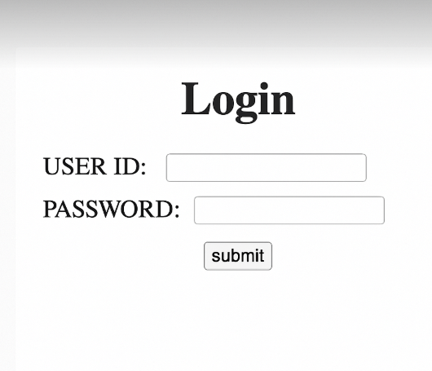

Practical 6

Write a JAVA servlet program to auto web page refresh (consider a webpage which is displaying date and time or stock market status. For all such type of pages, you would need to refresh your web page regularly; java servlet makes this job easy by providing refresh automatically after a given interval).

// Import required java libraries
import java.io.*;
import javax.servlet.*;
import javax.servlet.http.*;
import java.util.*;

// Extend HttpServlet class
public class Refresh extends HttpServlet {

// Method to handle GET method request.
public void doGet(HttpServletRequest request, HttpServletResponse response)
throws ServletException, IOException {

// Set refresh, autoload time as 5 seconds
response.setIntHeader("Refresh", 5);

// Set response content type
response.setContentType("text/html");

// Get current time
Calendar calendar = new GregorianCalendar();
String am_pm;
int hour = calendar.get(Calendar.HOUR);
int minute = calendar.get(Calendar.MINUTE);
int second = calendar.get(Calendar.SECOND);

if(calendar.get(Calendar.AM_PM) == 0)
am_pm = "AM";
else
am_pm = "PM";

String CT = hour+":"+ minute +":"+ second +" "+ am_pm;

PrintWriter out = response.getWriter();
String title = "Auto Page Refresh using Servlet";
String docType =
"<!doctype html public \"-//w3c//dtd html 4.0 " + "transitional//en\">\n";

out.println(docType +
"<html>\n" +
"<head><title>" + title + "</title></head>\n"+
"<body bgcolor = \"#f0f0f0\">\n" +
"<h1 align = \"center\">" + title + "</h1>\n" +
"<p>Current Time is: " + CT + "</p>\n"
);
}
// Method to handle POST method request.
public void doPost(HttpServletRequest request, HttpServletResponse response)
throws ServletException, IOException {

doGet(request, response);
}
}

Web.xml

<servlet>
<servlet-name>Refresh</servlet-name>
<servlet-class>Refresh</servlet-class>
</servlet>

<servlet-mapping>
<servlet-name>Refresh</servlet-name>
<url-pattern>/Refresh</url-pattern>
</servlet-mapping>

Output
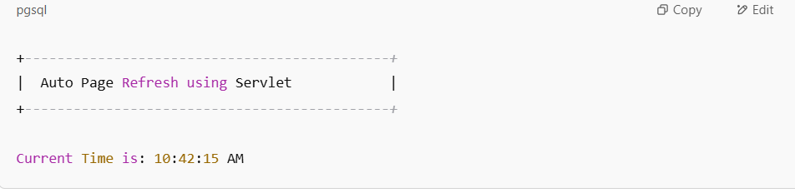

Practical 7

Write a program to develop aswing application with different layouts.

import javax.swing.*;
import java.awt.*;

public class LayoutDemo extends JFrame {

public LayoutDemo() {
setTitle("Swing Layout Demo");
setSize(500, 400);
setDefaultCloseOperation(EXIT_ON_CLOSE);
setLayout(new BorderLayout());

// Panel with FlowLayout
JPanel flowPanel = new JPanel(new FlowLayout());
flowPanel.setBorder(BorderFactory.createTitledBorder("FlowLayout"));
flowPanel.add(new JButton("Button 1"));
flowPanel.add(new JButton("Button 2"));
flowPanel.add(new JButton("Button 3"));

// Panel with GridLayout
JPanel gridPanel = new JPanel(new GridLayout(2, 2, 10, 10));
gridPanel.setBorder(BorderFactory.createTitledBorder("GridLayout"));
gridPanel.add(new JButton("Grid 1"));
gridPanel.add(new JButton("Grid 2"));
gridPanel.add(new JButton("Grid 3"));
gridPanel.add(new JButton("Grid 4"));

// Adding panels to main frame using BorderLayout
add(flowPanel, BorderLayout.NORTH);
add(gridPanel, BorderLayout.CENTER);

// Adding a button at the bottom using BorderLayout.SOUTH
JButton exitButton = new JButton("Exit");
exitButton.addActionListener(e -> System.exit(0));
add(exitButton, BorderLayout.SOUTH);
}

public static void main(String[] args) {
SwingUtilities.invokeLater(() -> {
new LayoutDemo().setVisible(true);
});
}
}

Output:
